School Handbook and agreement  How school families & staff work in partnership to support children’s learning and wellbeing.  www.thelondonacornschool.co.uk | Your family agreement  Page 2  Welcome from our Head Teacher  Page 5  History of the London Acorn School  Page 6  How our school is governed  Page 8  Meet the faculty  Page 11  Our unifying beliefs & future pathway  Page 12  Curiosity, love of learning and how to build it  Page 16  Technology  Page 20  The natural world  Page 23  Class & Social life  Page 26  Clear boundaries  Page 33  Pedagogy &  academic excellence  Kindergarten: Page 35  Main School: Page 43  Open-hearted approach  Page 50  Stronger together when we share information  Page 54

School handbook and agreement issued in academic year 2019/20.

Our school/family agreement
Family of: |  |  |  | Child name

Child name

Family/ School partnership agreement: |  | - If I have any concerns (no matter how small), I will raise them with our class teacher or head teacher. If I have any serious concerns or complaints I will follow the school policy (published on the school website) to address these. I will not publicise or broadcast complaints or concerns without giving the school reasonable opportunity to respond using the complaints procedure. I understand that persistent breaches of this agreement or total failure to comply may result in a termination of contract by the school and withdrawal from school classes.  I have examined the school handbook and agree to take all reasonable steps to uphold its principles and commit to the actions outlined in the boxes of this colour that appear within it.  - I will support all school staff as they strive their best to fulfil the obligations of the school set out in the right hand boxes at the end of each section of the handbook.

Family Finance Agreement: |  | I agree to make appropriate arrangements with the school office to pay school fees promptly and ensure that prompt payment is sustained.  If my family departs the school, I understand that one full term’s notice is required, or payment in lieu, to recover any deposit. Finance terms and conditions on the school website.  I understand that any extra educational support necessary for my child, or optional coaching sessions (ie. Music), will be subject to additional charge.
School agreement: |  | The School undertakes to take all reasonable steps to ensure that the educational principles outlined in this handbook are upheld and the actions outlined in the boxes of this colour are delivered. The school will do all it reasonably can to support each family to maintain this agreement.

Morden Cottage
Morden Hall Park
London SM4 5JD

Tel: +44 (0)20 8544 9769
www.thelondonacornschool.co.uk
info@thelondonacornschool.co.uk

The London Acorn School CIC is a not for profit Community Interest Company registered in England as company no. 8266022
Independent school registration number 315/60
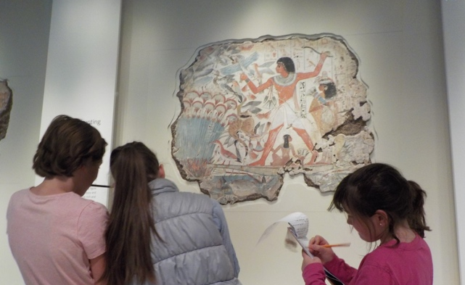

This handbook is the copyright of The London Acorn School 2019. Further copies are available from the school office.

